***EQUIFAX***

CMS Fusion

**SHIPPING**

**DOCUMENTATION**

Table of Contents

Shipping Tab 2

1. New Shipping process 3

5. Summary 6

# Shipping Tab

Shipping process deliver outcome to customer. Shipping tab will allow configure process for deliver different reports and output artifacts to customer.

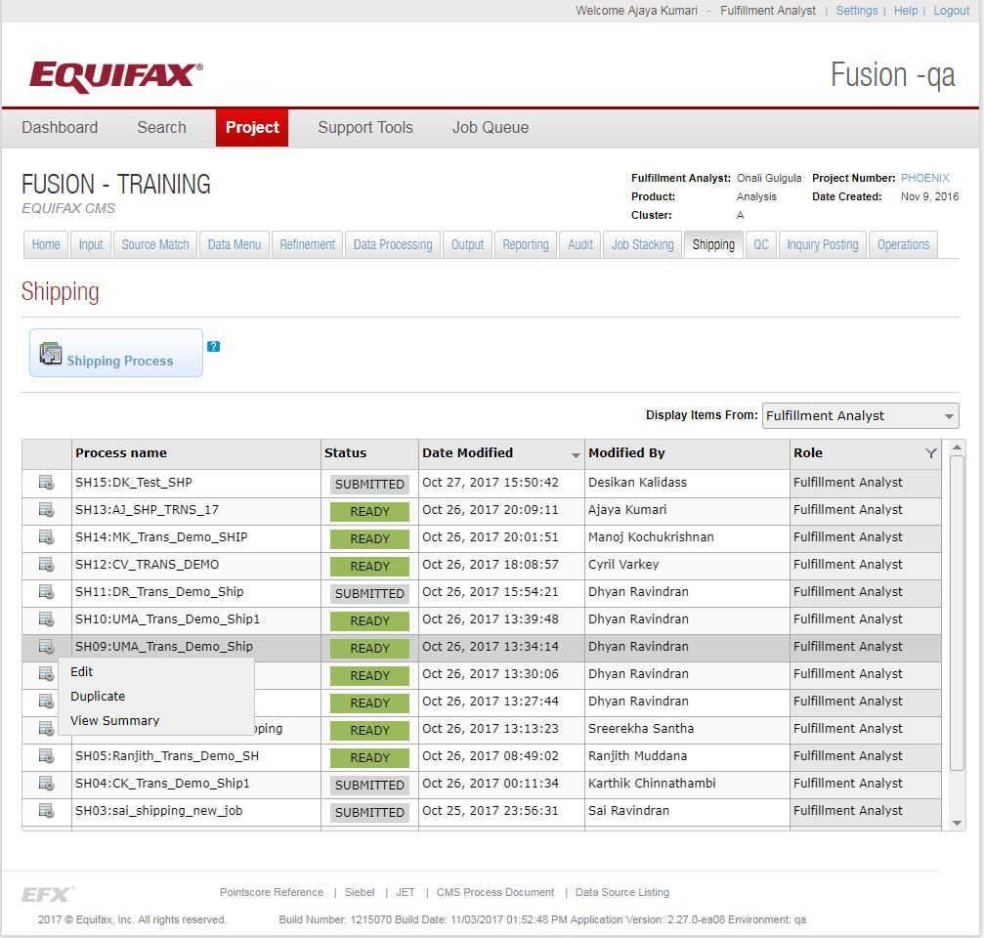

## View shipping Process Status

While clicking on the shipping tab, it will list the set of shipping processes created for the project and its details

* Process – The Process name used for the process.
* Status – The status of the process created.
* Date Modified
* Modified By
* Role – Represents different roles in the application. – Fulfilment Analyst, Programmers.
* Edit – If need to edit any option provided in the process before submitting.
* Duplicate – Provides an option to duplicate an already submitted process.
* View Summary – There is a high level view of what all options are selected for the process.

## New Shipping Process

This Wizard helps to add the options to import a file.

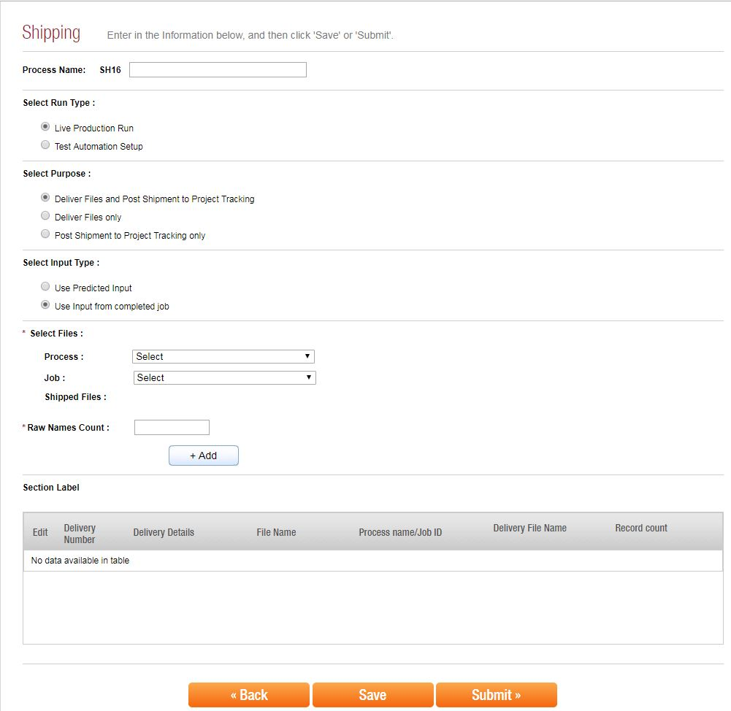

## Name the process

**Process Name:** A process name has a Process Id which is an Auto Generated Id. This will prefix the Process Name that is provided. In the screenshot above Process Id is SH16. So the process Name would be IP33: <name_of_the_process_given>.

## Select Run Type

Choose one appropriate option.

L**ive Production Run: -** deliver output file to customer with live production data.

**Test Automation Setup: -** For automate job stack execution. It’s used for testing purpose

## Select Purpose

Choose one appropriate option.

**Deliver Files and Post Shipment to Project Tracking: -** Deliver file to customer and update project tracking for further processes e like project accounting .g.: - financial system for billing purpose.

**Deliver Files only. : -** It will deliver output file to the customer but not tracked for project accounting. (E.g. scenario: Already delivered files will need to resend)

**Post Shipment to Project Tracking only** (scenario: already given file on outside fusion but need to track project)

## Select Input type

Choose one appropriate option

**Use Predicted Input: -** shipping configuration based on predicted information

**Use Input from completed job: -** will deliver output artifacts for completed job**.** (If job was completed then system will track process with completed job Id)

## Select Date (Filed available only for purpose as “Post Shipment to Project Tracking only”)

## Ship Date:

## Select Files

## Process: select appropriate process

## Job:  select appropriate job. If input type was “predicated input” , then job number automatically populated

## Shipped Files: tick appropriate files for delivery.

## Raw Names Count: (row name count used for other system like financial system for billing purpose)

## After selecting files, then add files to the system. Shipping File Delivery details popup will populated .Then populated details will display on section label section.

## Section Label

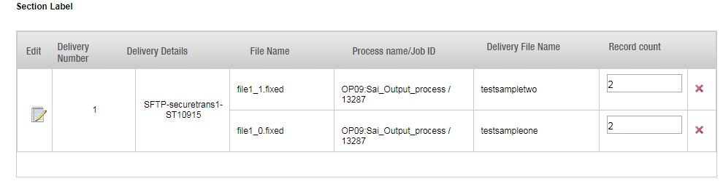

**Edit (Shipping file Delivery details )**

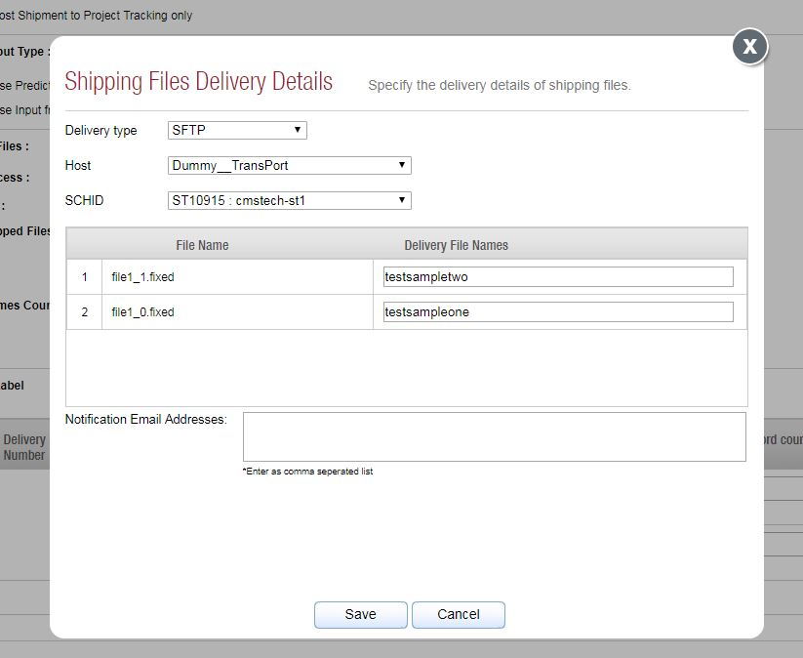

**Delivery type: -** choose appropriate delivery protocol and host information

These options are available for delivery type SFTP, FTP, Connect Direct and other.

FTP: - File transfer protocol

SFTP: - Secured File transfer protocol

Connect Direct: -user can choose appropriate script file for transfer file to consumer.

Other: - It will not transfer file to consumer. (E.g. scenario.- Files already shipped but we need to track as part of project accounting ) .

Provide appropriate delivery file names and email for authorized person for notification.

## Summary

This page shows the summary of the shipping process. It will show the layout and other configuration of the process. Before submitting the configuration, shipping process must be passed on QC process. QC tab will display all the shipping process along with depended process. User can approve or reject process based on the data verification. If all the validation successfully passed then shipping process can submit successfully.

